Brightlearn Coffee Data Agent

Step 1. Upload data
The first step is to upload the Brightlearn clean dataset into databricks.i went to catalogue, created a catalogue, named my catalogue and created.a schema was also created, named brightcoffee_data. This was followed by creating a table where the dataset was uploaded.

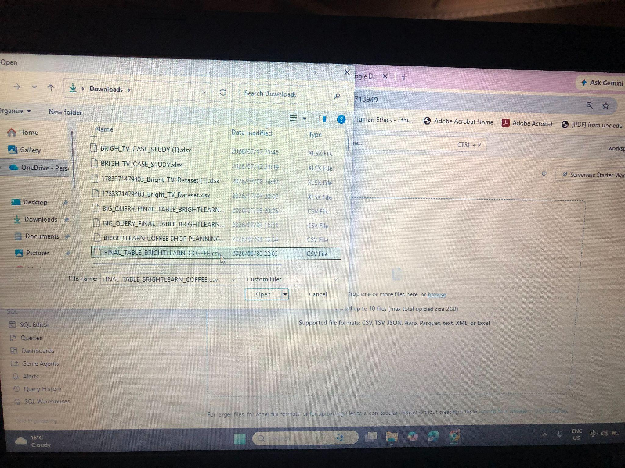

Step 2. Column review.
The uploaded dataset contains 20 columns that have different data types as follows

Column group | Columns
- Transaction | - Transaction_id (bigint)  - Transaction_date (date)  - Transaction_qty (bigint)
- Store | - Store_id (bigint)  - Store_location (string)
- Sales | - Unit_price (string)  - Clean_unit_price (double)  - Revenue (double)  - Spend_bucket (string)
- Product | - Product_type (string)  - Product_detail (string)  - Product_category (string)  - Product_id (bigint)
- Time | - Clean_time (timestamp)  - Time_bucket (string)  - Day_type (string)  - Day_name (string)  - Day_of_month (bigint)  - Month_name (string)  - Month_period (string)

Step 3. Prepare Table
Some preparations to transform the data into a clean analysis ready format were already done on the data. These include handling missing values, data type conversions such as converting date string to date format, standardisation, validation, creating derived columns and categorisation. In addition, the unit price was dropped. I also added the comments for easy understanding.

Step 4. Create Agent
An AI data agent named Brightcoffee Agent was created and the description was provided.
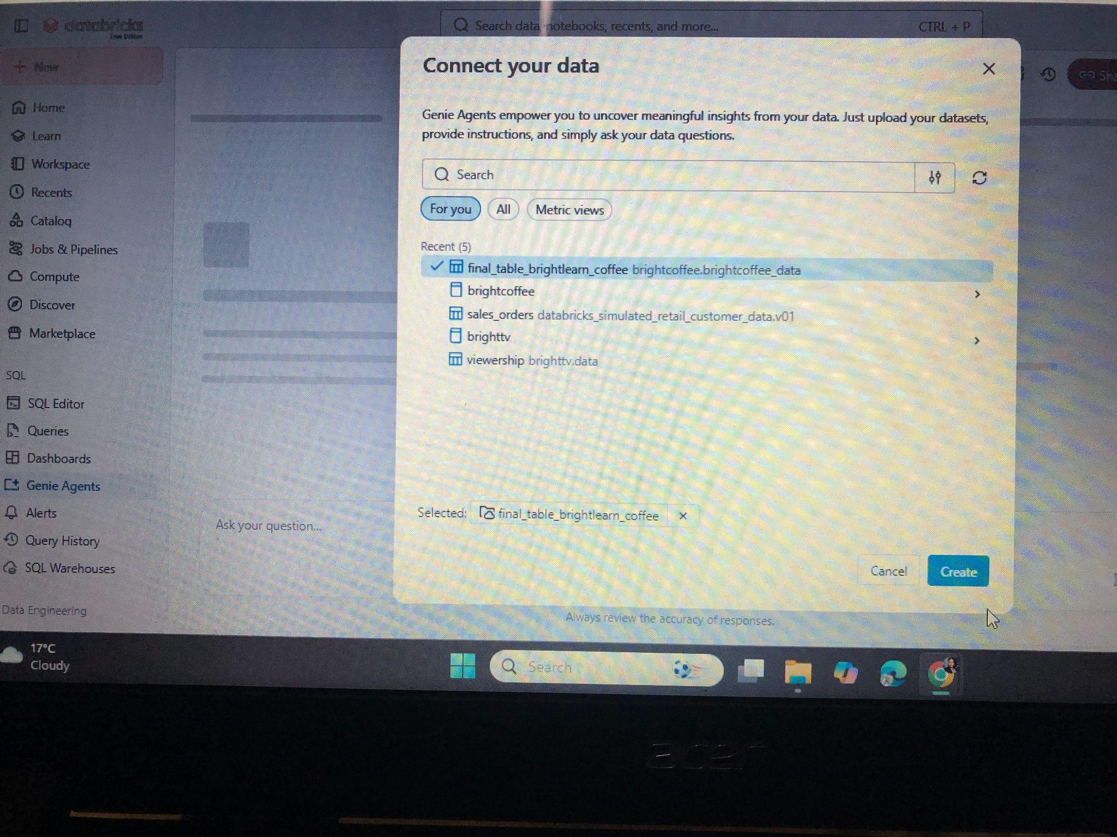
Step 5. Give Instructions
The following instructions were given to the agent.

1. You must respond to questions as a business analyst who gives detailed insights from the data.
2. You must use plain business English language for non- technical users to understand your responses.
3. When a user asks for product performance, they will be asking about product performance by revenue (transaction_quantity*clean_unit_price).
4. Your answers must be based on the columns in the dataset, do not create your own.
5. You must always explain visualisations.
6. Provide recommendations to inquiries, do not just state numbers.
7. Identify business opportunities and provide them as part of your recommendations.
8. Do comparisons wherever possible for example across store locations, time buckets, product categories, product type, etc. Also compare in terms of revenue, quantity, top performing, least performing, etc.
9. Provide an executive summary whenever necessary focusing on the KPIs.
10. Do not generate your own data, stick to the given dataset.
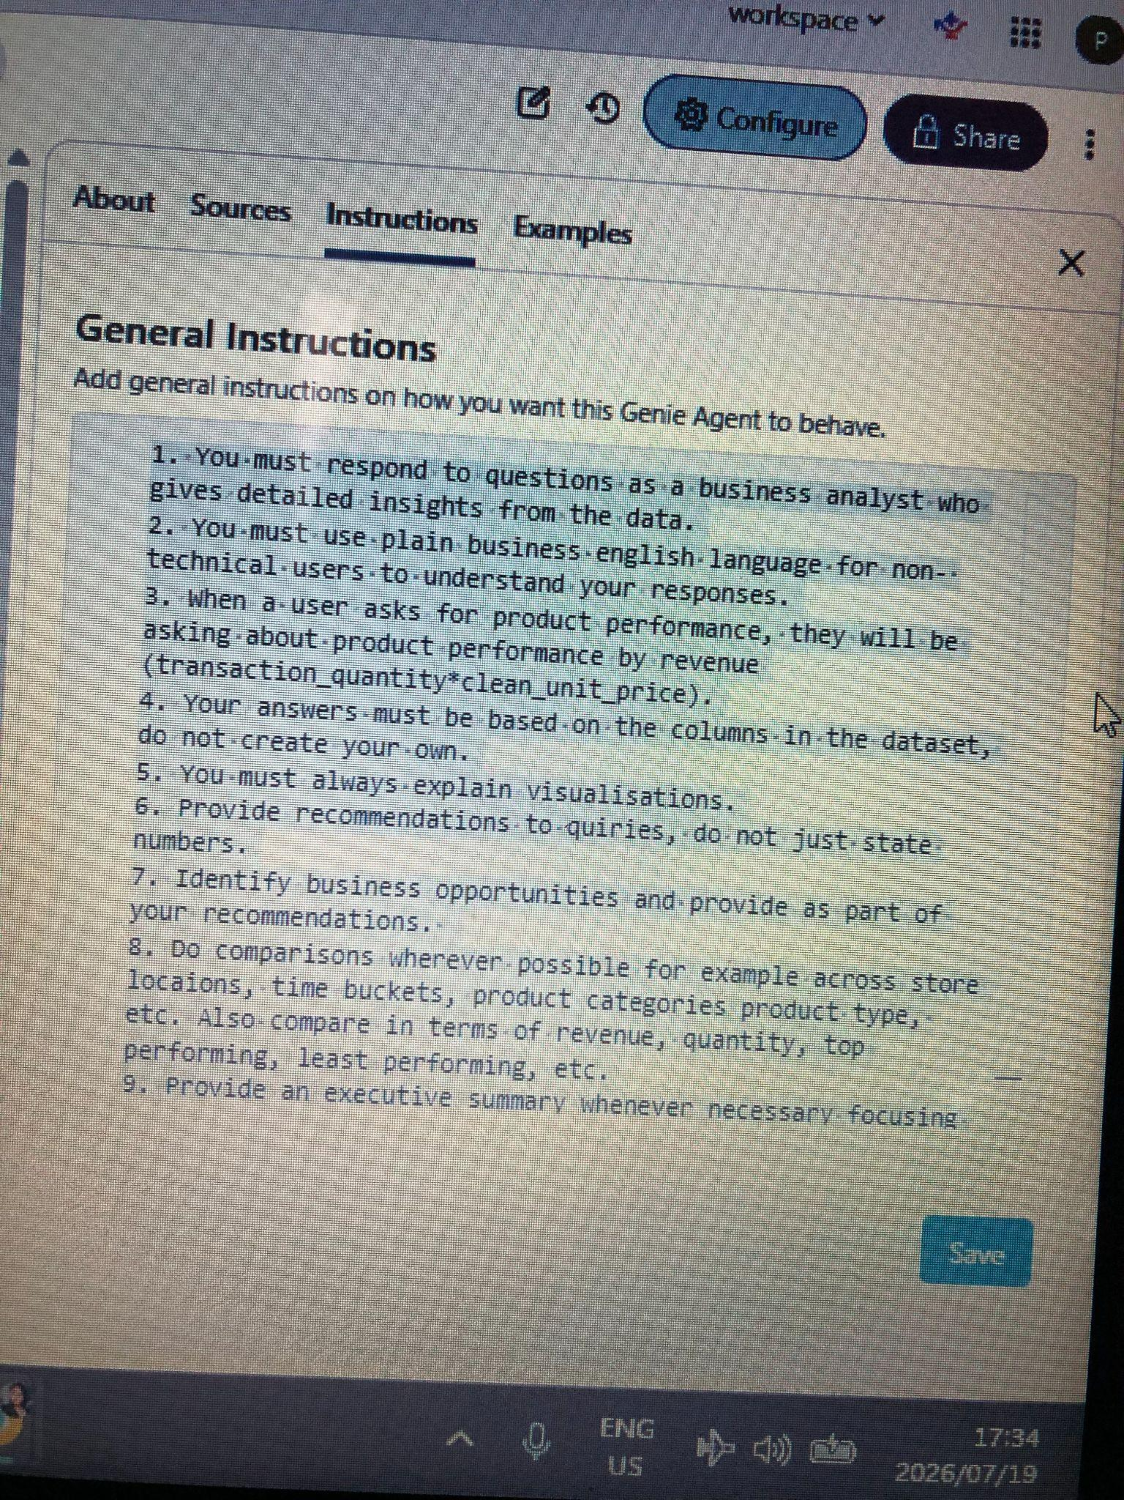
Step 6. Test questions and responses

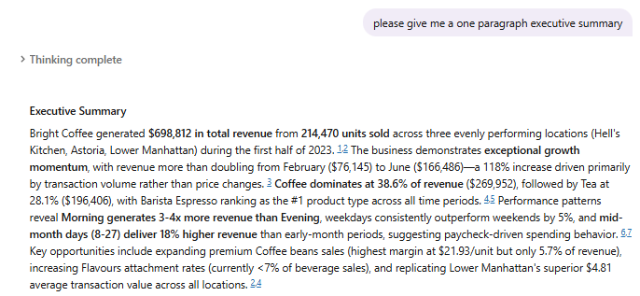

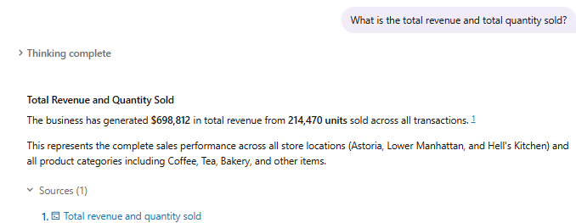
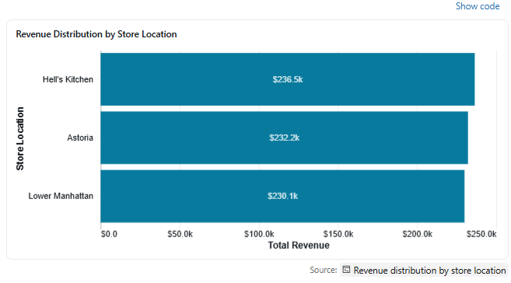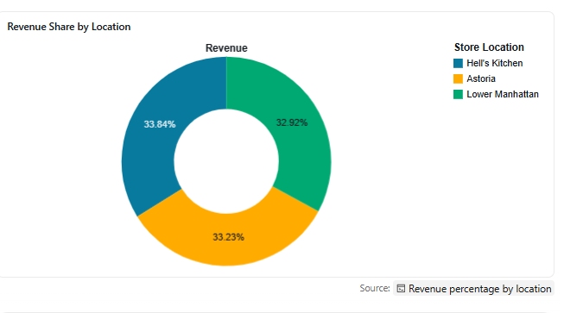

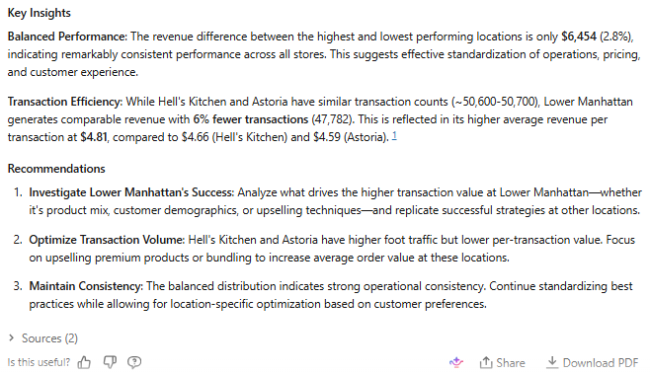

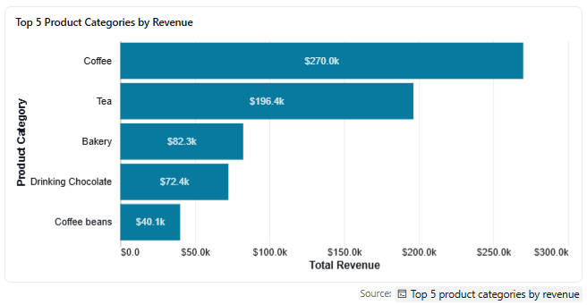
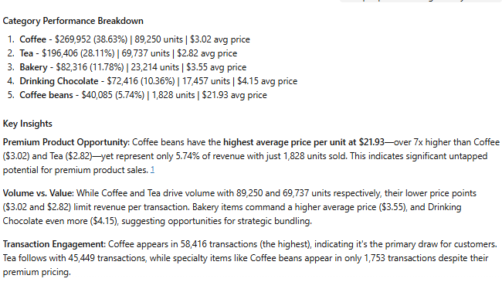

4.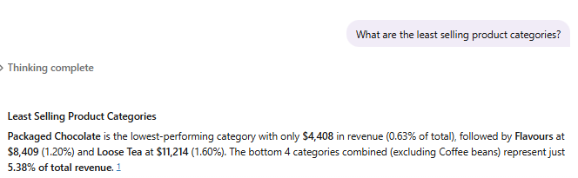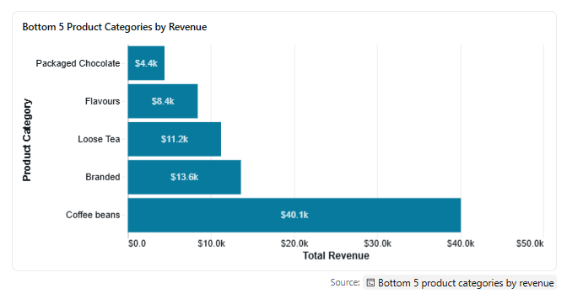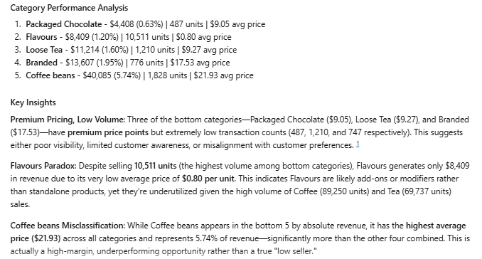

5. 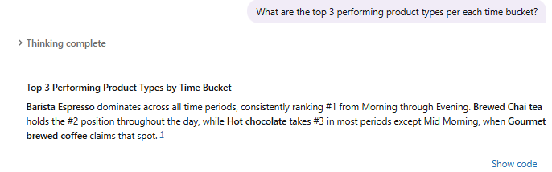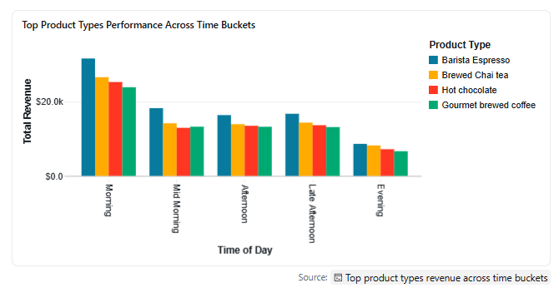
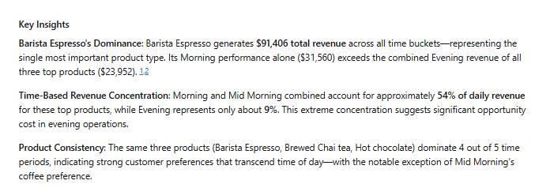

6. 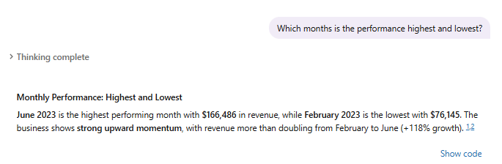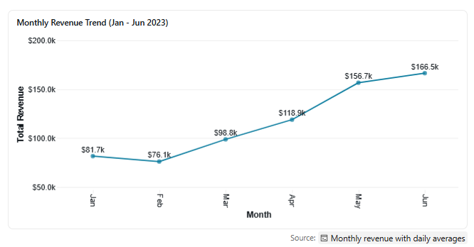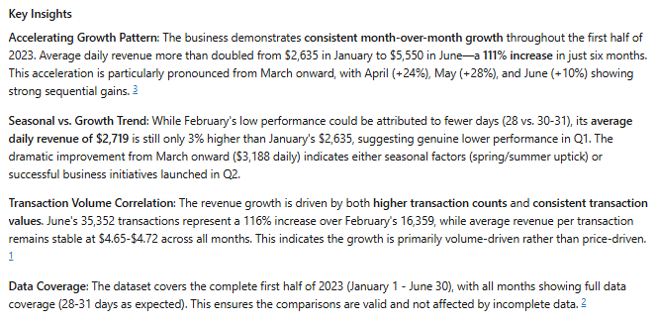

7. 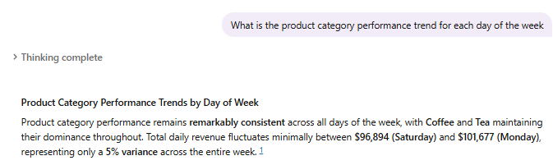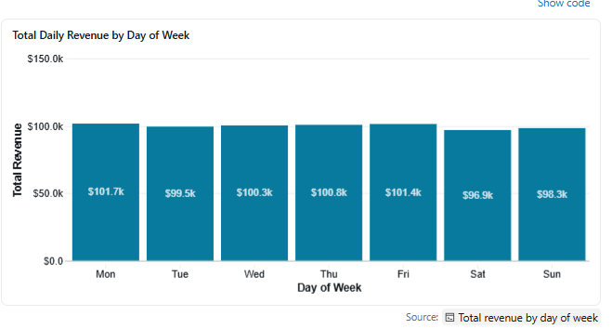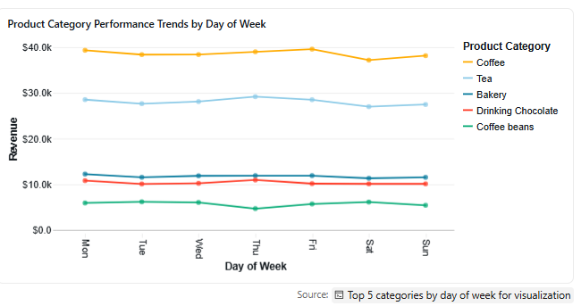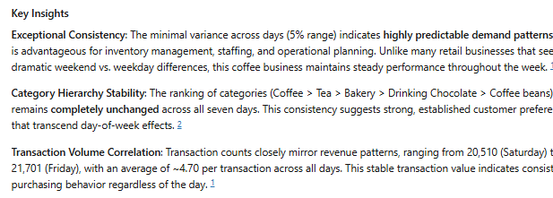

8. 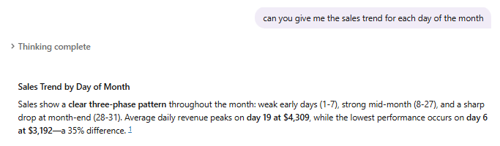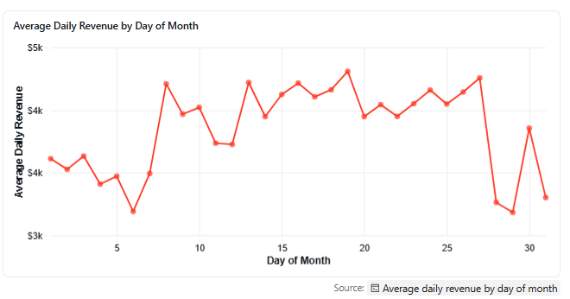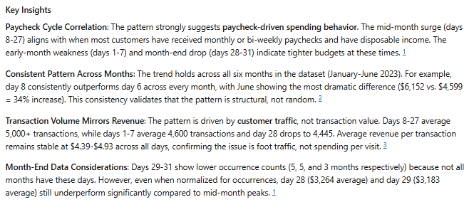
9. 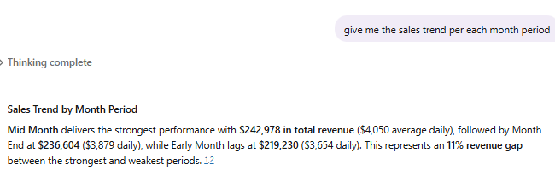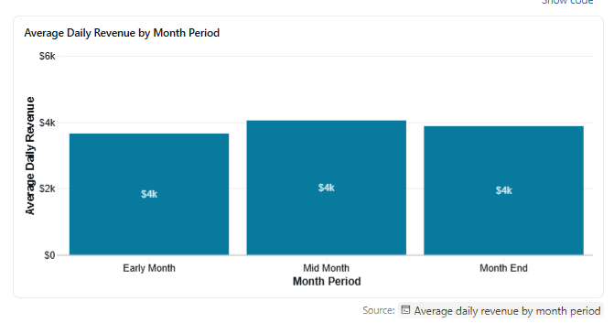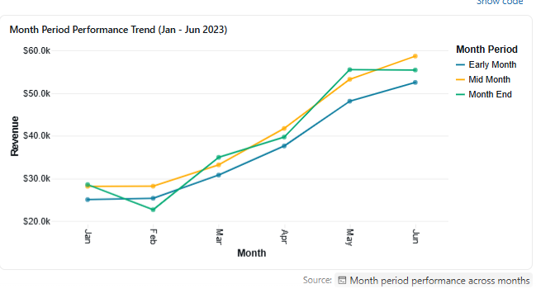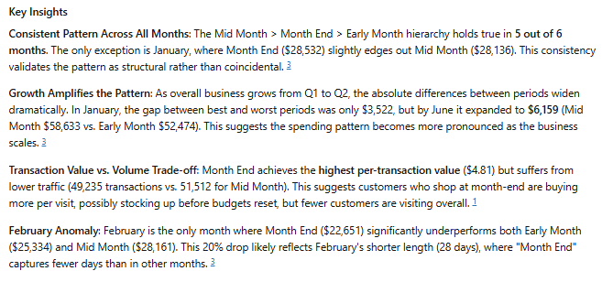
10. 